Application Development Fundamentals II 02 March 2021

1-dimensional Arrays Due date: Sun 7 March 2021 @8pm

Homework assignment 1a
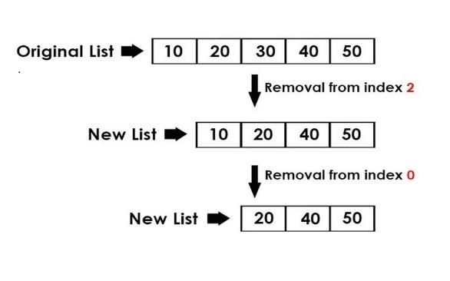
What is the pseudocode algorithm for removing an element, at a specified index, from an array, and writing the remaining elements to a new array?

Homework assignment 1b

Given two arrays of A and B respectively of sizes N₁ and N₂, the task is to calculate the product of the maximum element of the first array and minimum element of the second array.
Write the pseudocode algorithm for your solution.

Homework assignment 1c

Given two arrays:
String[ ] rank = {“2”, ”3 ”, “4 ”, “5 ”, “6 ”, “7 ”, “8 ”, “9 ”, “10 ”, “J ”, “Q ”, “K ”, “A”};
String[ ] suit = {“♠”, “ ♡”, “♢”, “♣”};

String[ ] deck = new String [52];

Write Java statements, using nested for loops, to put all the cards in the deck array. Then display/print the contents of the deck.

Sample output:
